**STILL ALIVE MEDICAL JOURNAL**

**Version 1.2**

**WOUNDS AND INFECTION**

Wounds come from three different sources: melee weapons, guns, and zombie bites. Melee and gun wounds won’t cause a player to become more infected unless the player comes to see the **Doctor** or **Surgeon** without getting their wound wrapped first by someone with the **Medic** skill. Zombie bites, however, are a different matter. They’re extremely infectious and will increase your infection rating (percentage of how infected you are) just by receiving them; *but*, coming to the **Doctor** or **Surgeon** with an unwrapped zombie wound will cause you to receive *triple* the normal infection amount.

Your Infection Rating will increase slowly over your character’s lifetime. Despite extensive medical research, there isn’t currently a way to lower your infection rating, so right now the best medicine is prevention.

Each character starts at 0% infection and will gain a small amount each time an infected wound of theirs is treated. This small amount is determined by a dice roll. To start out, every character rolls a 12-sided dice and the result is added to their Infection Rating.

A character *can* become more resistant to the infection, however. The **Infection Resistance** skills (1-4) reduce the number of sides on the dice that’s rolled down to 10, 8, 6, and 4 respectively.

Whenever your Infection Rating passes a milestone (25%, 50%, and 75%), during checkout that night, a percentage will be rolled. If the number rolled is less than your current Infection Rating, you character gives in to the infection in their body and they become a zombie. This kills your character. There are *also* ways to make your body more resistant to *this* as well: The **Will to Live** skills increase your changes of survival immensely. **Will to Live 1** allows the player to reroll their percentage if they fail the first time. **Will to Live 2** is probably one of the best skills in the game. If a player fails both their normal roll AND their **Will to Live 1** roll, they can flip a coin. If the result is heads, they survive. If the result is tails, they die. If your character possesses a **Gambler’s** skill (**Gambler’s Luck, Gambler’s Eye, Gambler’s Talent,** or **Gambler’s Heart**) you’re allowed another coin flip for *each* **Gambler’s** skill you possess! This means that if you have all 4 **Gambler’s** skills, you’d get to flip the coin 5 times, and if any of them are heads, you survive!

After you surpass 75% infection, a new percentage will be rolled at the end of *each* event! If your infection Rating gets that high, make sure you take the skills necessary to survive!

Although there is no current way to reduce the infection’s grasp on you, the potential to develop a pharmaceutical that could do that is very real. Any person with the **Advanced Medical Research** skill can attempt to research new medicines that could make living at camp a much more survivable task or create already existing pharmaceuticals.

On the subject of pharmaceuticals, the list of discovered Pharmaceuticals is can be found below:

|  |  |  |  |  |
| --- | --- | --- | --- | --- |
| **NAME** | **DESCRIPTION** | **USE** | **AVERAGE COST** | **REPRESENTATION** |
| Adreaniline | Pumps your body full of adrenaline. | Allows the user to ignore all melee and zombie wounds for one full scenario. This does not apply to wounds gained from being dragged to the ground by zombies or bullet wounds. | 20 | Orange TicTacs |

You may take each type of pharmaceutical *once* per event, and only someone possessing the **Pharmaceuticals** skill can administer them to players.

**RELEATED SKILLS**

**Advanced Medical Research**

* + ***Prerequisites***: Pharmaceuticals, Surgeon
  + ***Cost/Tier***: 4
  + ***Description***: If a cure is ever going to be found, you’ll be the one to do it.
  + ***Explanation***: Allows the player to craft known Pharmaceuticals and discover new ones. This skill allows for other plot-related research as well, but we’re not going to give anything away!
  + ***Limitations***: None.
  + ***Type***: Profession
  + ***Notes***: None.

**Doctor**

* + ***Prerequisites***: Medic
  + ***Cost/Tier***: 3
  + ***Description***: Bring out yer dead.
  + ***Explanation***: Allows you to treat the wounds of players bitten by zombies and hit by melee weapons. You CANNOT treat bullet wounds. Treating a wound takes 2 minutes, unless it’s a chest wound which takes 5 minutes. The chart to help determine how to treat wounds can be found in the Still Alive Medical Journal.
  + ***Limitations***: Must have Medical Supplies bag on hand and all work must be done at camp. Additionally, the medical supplies back should contain the Still Alive Medical Journal.
  + ***Type***: Profession
  + ***Notes***: None.

**Medic**

* + ***Prerequisites***: -
  + ***Cost/Tier***: 2
  + ***Description***: What’s better than open wounds? Medical Wraps!
  + ***Explanation***: This skill allows you to wrap a wound on any character. Wrapping a wound requires a wrap from a medical kit to be tied around the corresponding wound. Wrapping a wound requires 10 seconds. Wrapping a wound DOES NOT remove the crippled condition. You may also wrap your own wound, but it takes twice as long (20 seconds).
  + ***Limitations***: In order to use any medical skill, a medical kit is required. A medical kit must consist of medical wraps, surgical scissors, cloth, and a small bottle full of water or a similar liquid [used as antiseptic or alcohol]. If you run out of medical wraps, you cannot wrap wounds.
  + ***Type***: Profession
  + ***Notes***: None.

**Surgeon**

* + ***Prerequisites***: Doctor
  + ***Cost/Tier***: 4
  + ***Description***: Scalpel!
  + ***Explanation***: An upgrade to the Doctor skill. Allows you to treat the wounds players with gunshot wounds. Treating a bullet wound (wrapped or unwrapped) takes 5 minutes unless it’s a bullet wound to the chest, which takes 10 minutes.
  + ***Limitations***: Must have Medical Supplies bag on hand and all work must be done at camp. Additionally, the medical supplies back should contain the Still Alive Medical Journal. In order to preform surgeries, your medical bag must also contain an apron, and a medical mask of some kind.
  + ***Type***: Profession
  + ***Notes***: None.

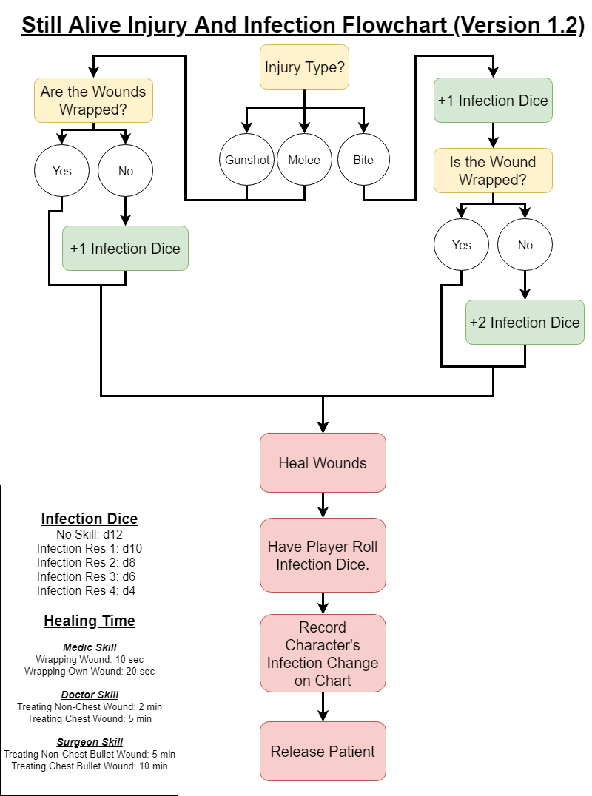

|  |  |  |
| --- | --- | --- |
| **PLAYER NAME** | **CHARACTER NAME** | **INFECTION AMOUNT** |
|  |  |  |
|  |  |  |
|  |  |  |
|  |  |  |
|  |  |  |
|  |  |  |
|  |  |  |
|  |  |  |
|  |  |  |
|  |  |  |
|  |  |  |
|  |  |  |
|  |  |  |
|  |  |  |
|  |  |  |
|  |  |  |
|  |  |  |
|  |  |  |
|  |  |  |
|  |  |  |
|  |  |  |
|  |  |  |
|  |  |  |
|  |  |  |
|  |  |  |
|  |  |  |
|  |  |  |
|  |  |  |
|  |  |  |
|  |  |  |
|  |  |  |
|  |  |  |
|  |  |  |
|  |  |  |
|  |  |  |
|  |  |  |
|  |  |  |
|  |  |  |
|  |  |  |
|  |  |  |
|  |  |  |
|  |  |  |